- 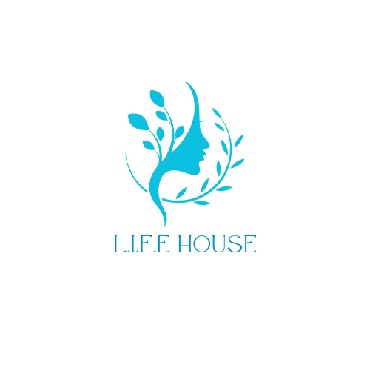  - Volume 1 | Issue 1  March 2024 | L.I.F.E. House  Newsletter  March 2024
For you formed my inward parts; you knitted me together in my mother’s womb.  Psalm 139:13 | Specific Prayer needs at this time:  A house mom. The first mother, first baby, and all the mothers and babies to come. That God prepare us for them as God prepares them for us. The neighbors around the home to soften and see the heart of what we are doing in obedience to God. The year review upcoming in May to continue our approval.  THE NEW YEAR  As 2024 begins, we are excited about all the things happening at L.I.F.E. House. We have been working on the logistics of the property itself and preparing it for mothers and babies to come. The home has furnished with furniture, kitchenware, bedding, towels, bathroom necessities, etc, and most of all, love.  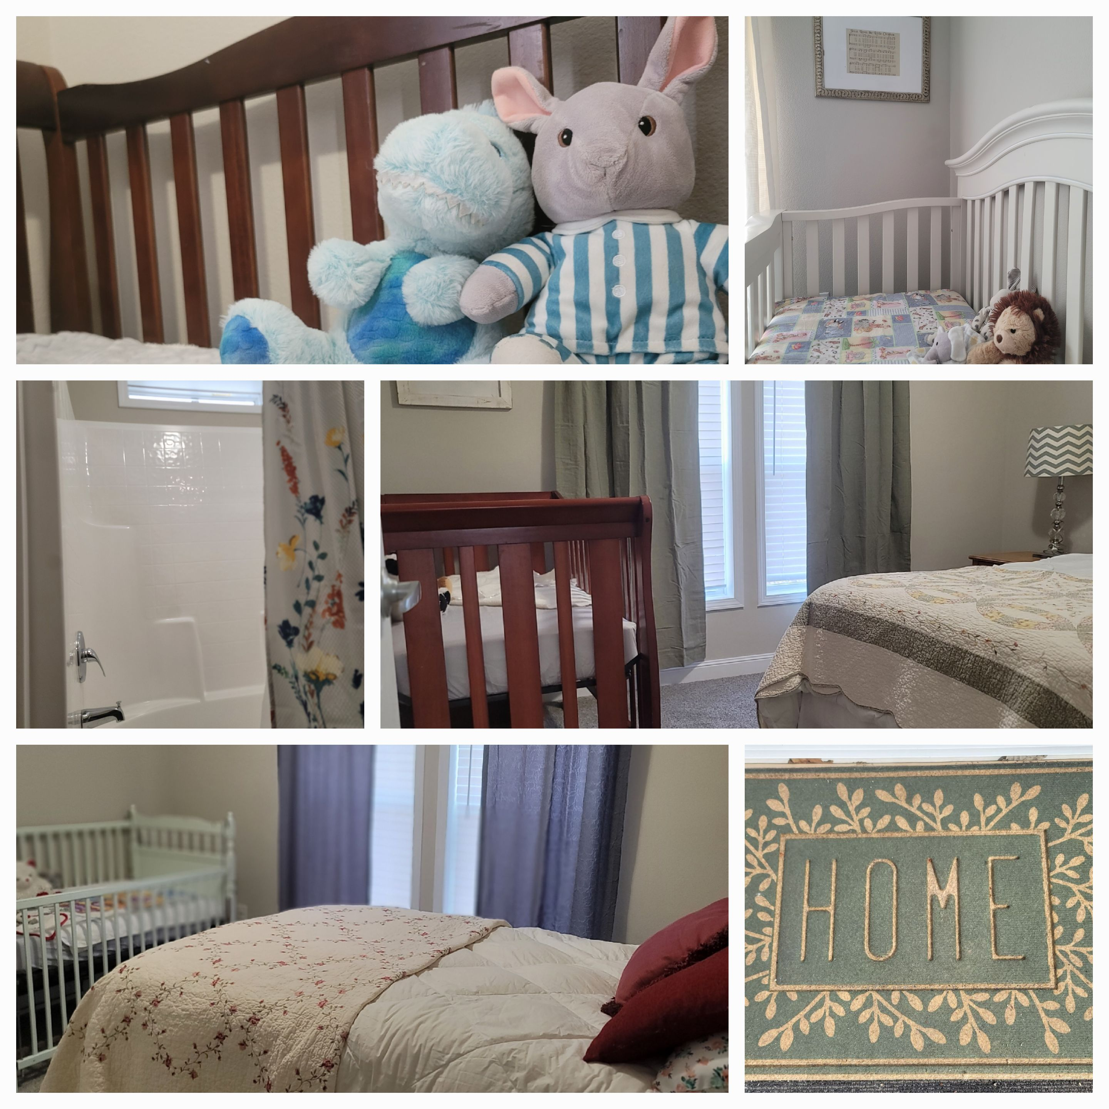
I praise you, for I am fearfully and wonderfully made. Wonderful are your works; my soul knows it very well  Psalm 139:14 | We have volunteers in place to help moms apply for healthcare, get healthcare, get their GED, apply for college, resumes, job interview skills, and banking literacy classes. A labor and delivery nurse/ lactation specialist volunteer that will help guide in care for mom and baby. We want to come along side women to let them know they were designed by God to become mothers and they can do it.  Shocking Statistics  Aid Access, the only online telemedicine service suppling medication abortion via mail, is currently getting around 250 requests each month from Mississippians.  Mississippians accounted for 576 of the 4,551 abortions patients at Alamo clinic in Southern Illinois.  According to WHO (world health organization), 73 MILLION induced abortions take place worldwide each year.  Ten months into 2023 there were 878,000 abortions in the US. That is approximately 88,000 abortions per month.  According to FDA, 5.9 MILLION women have used abortion pill in the US. That is the entire population of the state of Colorado.  Thank You  To all those who are and have contributed to L.I.F.E. House!  Southern Housing Fulton; Oak Grove Baptist Church; Air & Heat Service Co; Ronnie Young; Jamie Dickinson; Boyd & Sandra Tidwell; Electrical Repair & Installation; GRACE women of First Baptist Church Belmont; Nesbit First Baptist Church; Heartland Hands; House of Grace; Carol Vaughn; Kelly Hendricks; Tiffany Zolliecoffer; Chasity Zolliecoffer  L.I.F.E House  P.O Box 638  Hernando, MS 38632  chooselife.house@gmail.com  901-734-3151

